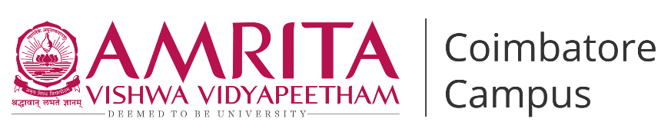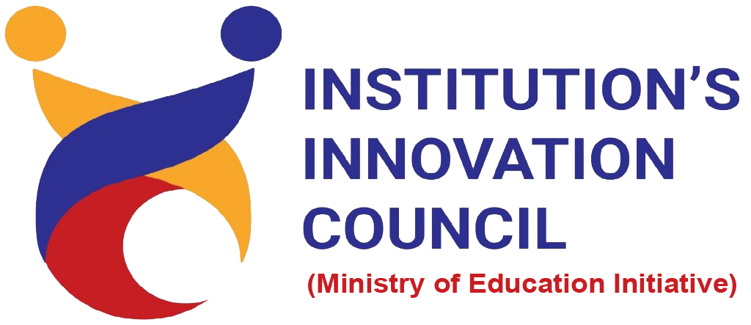

**Live-in-Labs : Field Visit to Palangulam**

**Activity Category :** Self – Driven Activities

**Event Title :** Live-in-Labs : Field Visit to Palangulam  
**Dates :** June 4 – 13, 2025  
**Occasion/Theme :** Experiential Learning  
**Organized by :** Live-in-Labs, Amrita Vishwa Vidyapeetham

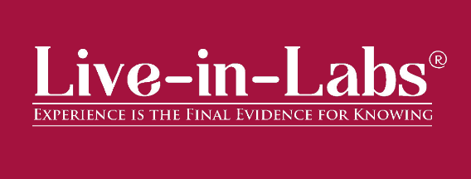

**Overview**

The Live-in-Labs® project in **Palangulam** was carried out by a team of Amrita students under the mentorship of **Mr Sriram S**. The focus of the visit was to address the challenge of **low agricultural yield** through innovative, sustainable, and community-driven solutions.

The team interacted with villagers, conducted surveys, and studied the socio-economic conditions to identify root causes of the problem. Based on this, solutions such **Solar-Powered Community Micro-Irrigation & Water Management** and **Integrated Organic Farming & Village Composting Program**were proposed. These interventions combine scientific knowledge with frugal innovation, making them both cost-effective and scalable.

The visit provided the team with hands-on exposure to applying classroom concepts in real-world contexts. Students gained valuable knowledge on design thinking, grassroots innovation, and community engagement. The collaboration between Amrita and international students, who supported during Field Visits, enriched the process with diverse perspectives, ensuring that the solutions were both technically sound and socially acceptable.

Overall, the project demonstrated how grassroots challenges can be transformed into opportunities for innovation and entrepreneurship. The solutions identified have the potential for further prototyping, incubation, and replication in other rural contexts, aligning with the vision of IIC to foster innovation-driven impact.

**Planning & Execution**

The project was planned in advance based on the schedule prepared and submitted during the Live-in-Labs® workshop. The schedule served as a roadmap, outlining each stage of the work from preliminary study to field immersion and final reporting. In the initial phase, the team conducted a background study of the village and gathered secondary data to understand the broader context of the problem. This was followed by structured planning of surveys, community interactions, and technical assessments, all aligned with the timelines agreed upon.

**Day 1: 04/06/25 (Wednesday)**

**•** Interaction with village co-ordinator to understand study context and gain permissions.  
• Conducted first village visit to observe living conditions and key village activities.  
• Built rapport with villagers through informal conversations.  
• Applied AEIOU framework for initial observations.

**Day 2: 05/06/25 (Thursday)**

• Focused observation of significant places (Anganwadi, School).  
• Started drafting a rough resource map.  
• Noted AEIOU elements and six senses during field observation.  
• Conducted informal interviews and discussions with villagers.  
• Prepared basic structure and demographic data for the resource map.

**Day 3: 06/06/25 (Friday)**

• Conducted unstructured household interviews to capture personal stories.  
• Performed transect walk to gather spatial and environmental information.  
• Observed and recorded interactions in the village.  
• Engaged kids with activities to better understand family dynamics.

**Day 4: 07/06/25 (Saturday)**

• Conducted semi-structured household interviews for more guided data collection.

• Facilitated individual unstructured interviews  
• Validated preliminary data from previous observations.  
• Conducted brainstorming session to organize data and identify patterns.  
• Prepared focus group discussion to structure problem identification.

**Day 5: 08/06/25 (Sunday)**

• Finalized structured household interviews to improve data quality.  
• Cross-validation of data from brainstorming session.  
• Prepared rough problem tree to identify core issues.  
• Planned focus group for further problem refinement.

**Day 6: 09/06/25 (Monday)**

• Continued structured household interviews to deepen insights.  
• Visited local shops to study inflow and outflow of goods.  
• Built persona and scenario frameworks to represent typical villagers.  
• Updated problem tree with refined insights.

**Day 7: 10/06/25 (Tuesday)**

• Visited significant places (healthcare, ration shop) for detailed observations.  
• Validated income, expenditure, and inflow-outflow data using Venn diagrams.  
• Identified and sanitized the problem tree.  
• Held second brainstorming session to discuss ideas.

**Day 8: 11/06/25 (Wednesday)**

• Conducted focused household interviews addressing key problems.  
• Discussed resource map details with villagers for accuracy.  
• Finalized resource map collaboratively.  
• Finalized problem statement through focus group discussions.

**Day 9: 12/06/25 (Thursday)**

• Conducted second transect walk for further verification of observations.  
• Cross-validated data in relation to the problem statement.  
• Used Empower App to compile and organize data.

**Day 10: 13/06/25 (Friday)**

• Verified collected data and findings.  
• Displayed the report to the village community for feedback.  
• Held final meeting with villagers and team to conclude the field study.

**Impact & Outcomes**

* **Innovation :** The project demonstrated how grassroots challenges can inspire innovative, frugal solutions. By integrating scientific concepts with local knowledge, the team is planning to design interventions such as Solar-Powered Community Micro-Irrigation & Water Managementthat will be low-cost, adaptable, and scalable. This process highlighted the power of student-led innovation to create practical and impactful models in rural development.
* **Design Thinking :** The outcomes of the project were achieved by following a design-thinking approach. Students empathized with villagers through surveys and discussions, defined the root problems, ideated possible solutions, and tested their feasibility with the community. This systematic method ensured that the solutions were not only technically feasible but also socially acceptable and context-specific.
* **Entrepreneurship Potential :** Several proposed solutions have the potential to evolve into entrepreneurial models or startups. For example, the Solar-Powered Micro-Irrigation system can be further developed into a product or service that benefits multiple villages, creating employment opportunities while addressing community needs. This outcome aligns with IIC’s vision of nurturing student entrepreneurship and translating innovation into scalable ventures.
* **Sustainability :** The solutions emphasized long-term sustainability by making use of locally available resources and building capacity within the community. As a result, the interventions can be maintained by villagers themselves without heavy dependence on external support. This ensures that the outcomes continue to create impact even after the project phase ends.
* **Societal Impact :** The immediate impact of the project was raising awareness among community members about alternative and innovative practices. In the long run, the solutions are expected to improve living standards, reduce resource-related hardships, and strengthen the resilience of the village. The project also encouraged local youth to view innovation as a tool for solving their own challenges.
* **Collaboration and Knowledge Sharing :** A significant outcome of the project was the knowledge exchange that took place between Amrita students, international peers, and the local community. This cross-cultural collaboration enriched the learning experience, allowed multiple perspectives to be considered, and helped design solutions that were technically sound, socially relevant, and globally informed.

**Participation**

1. **Student Members** : Conducted Surveys, Identified the Problem and Designed Solutions.

* Saana Poovaiah N (CB.EN.U4MEE24142) - Dept. Of Mechanical Engineering
* Tejhashwini C B (CB.SC.U4CSE24755) - Dept. Of Computer Science and Engineering
* Somisetty Veda Sai (CB.SC.U4CSE24448) - Dept. Of Computer Science and Engineering
* Visruth Thayyil Vijind (CB.SC.U4CSE24557)- Dept. Of Computer Science and Engineering
* Nethra R (CB.EN.U4EEE24031) – Dept. Of Electrical and Electronics Engineering

1. **Faculty Member (Mentor)** : **Mr Sriram S** *Department of Computer Science and Engineering*- Provided continuous guidance and supervision.

**Contribution to SDGs**

The project contributes to several United Nations Sustainable Development Goals (SDGs):

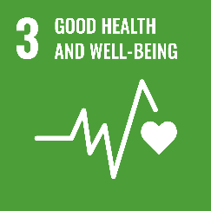

By providing clean drinking water and organizing health awareness drives and community health camps to address skin diseases caused by pest attacks, the project improves health outcomes for the community.

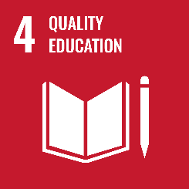

Knowledge sharing, awareness programs, and cross-cultural learning enhanced educational opportunities for both villagers and students.

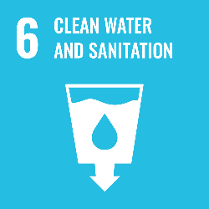

Proposed solutions such as solar-powered community micro-irrigation and water management directly improve access to safe water and sanitation facilities.

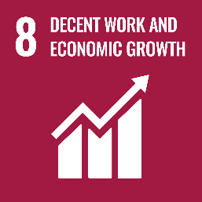

Entrepreneurial potential of the solutions encourages community-based enterprises and livelihood opportunities.

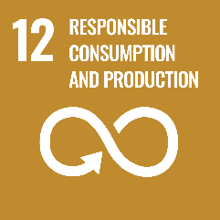

The solutions emphasize frugal innovation, waste reduction, and sustainable use of resources.

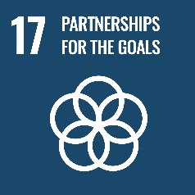

Collaboration between Amrita students, and the village community reflects strong global partnerships for sustainable development.

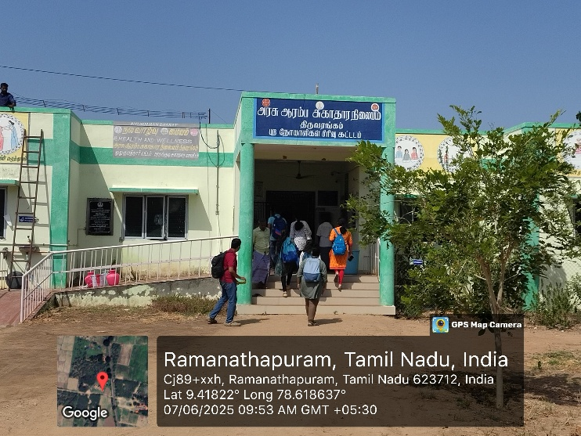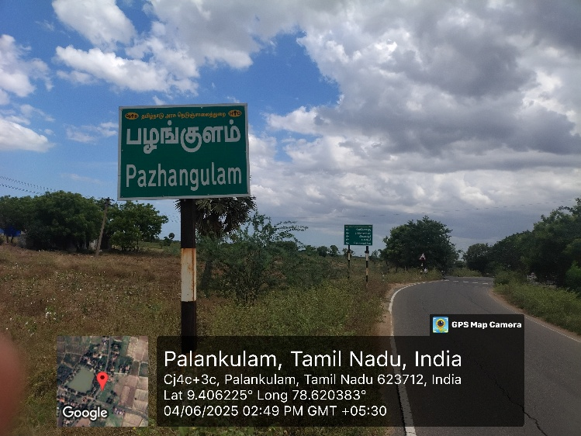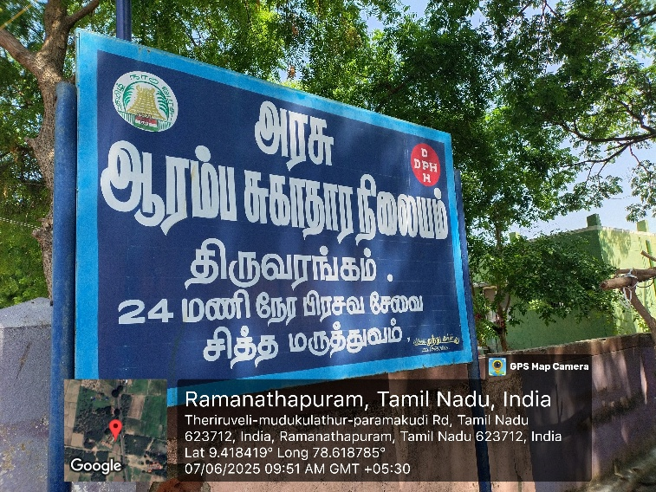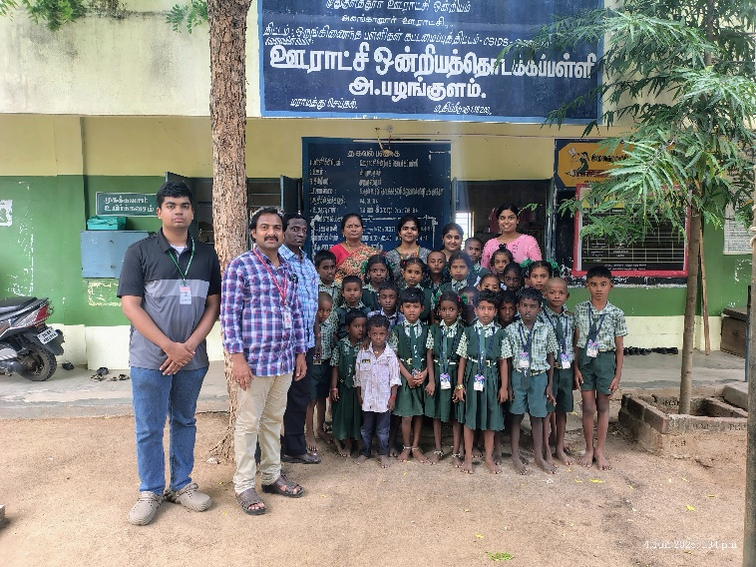**Publicity**

